Table of Contents
1.Background 3
1.1 Project Goals & Results Summary 3
1.2 Million Song Dataset Introduction 3
2. Distributed Data Processing 4
Q1: Exploratory Data Analysis and Dataset Profiling 4
Q2: Data Preprocessing and Dynamic Schema Definition 6
3. Audio Feature Analysis and Genre Classification 7
Q1: Audio Feature Merger and Statistical Exploration 7
Q2: Binary Classification Modeling (Rap vs. Others) 10
Q3: Multiclass Genre Classification Modeling 13
Q4: Hyperparameter Tuning and Optimization Strategy 15
4. Collaborative Filtering and Song Recommendation System 17
Q1: Dataset Attributes and Long Tail Distribution Analysis 17
Q2: Training and Evaluating Implicit Alternating Least Squares (ALS) Model 19
5. Conclusions 20
6. References 21

List of Figures
Figure 1 MSD Directory Structure 5
Figure 2 Feature Correlation Heatmap (Before Removal) 9
Figure 3 Feature Correlation Heatmap(After Removal) 9
Figure 4 Genre Distribution (Imbalance Check) 10
Figure 5 Per-Genre F1 Score for Multiclass Logistic Regression 15
Figure 6 Song Popularity and User Activity Distributions (Log-Log Scale) 18

List of Tables
Table 1 Dataset Overview 5
Table 2 Summary Statistics for Selected Audio Features 8
Table 3 Comparison of Classification Algorithms 11
Table 4 Binary Classification Performance on the Test Set 13
Table 5 Performance Metrics by Genre for Multiclass Logistic Regression 14
Table 6 Key Hyperparameters for Each Classification Algorithm 15
Table 7 Descriptive Statistics of Playcount 18
Table 8 Dataset Statistics After Filtering 19
Table 9 Ranking Metrics of the ALS Model on the Test Set 20

1.Background

1.1 Project Goals & Results Summary

This hands on project explores and analyzes the Million Song Dataset (MSD), using Apache Spark to clean large scale data, join tables, extract features, and train, tune, and evaluate machine learning models to ultimately establish a recommendation system that suggests songs to users. During the data processing stage, I accessed cloud data to analyze its structure, and instead of loading raw ARFF files directly, I parsed the separate attribute metadata files to dynamically generate the Spark StructType schema and systematically renamed the columns for machine learning. In the audio similarity analysis stage, I trained three types of binary classification algorithms, including Logistic Regression, Random Forest, and Gradient Boosted Trees (GBT) as well as one multiclass classifier to predict track genres from audio features, achieving an AUROC of up to 0.94 in the binary task. Finally, the song recommendation stage trained an implicit Alternating Least Squares (ALS) collaborative filtering model on a filtered subset of 661,103 users and 161,173 songs, evaluating its performance using Precision@10, NDCG, and MAP.

1.2 Million Song Dataset Introduction

The Million Song Dataset (MSD) was contributed by The Echo Nest and LabROSA research groups. This dataset includes metadata, the Taste Profile subset, the MSD AllMusic Genre Dataset (MAGD), and audio feature datasets. The metadata contains one million songs with over 50 fields, such as Song ID, Track ID, Artist ID, release year, and tempo. In the MSD, a song refers to the abstract musical work, while a track refers to a specific recording of that song, meaning one song may have multiple tracks that differ in how they were recorded or produced. The Taste Profile subset provides play counts rather than explicit ratings from real users, which makes it an implicit feedback dataset. Unlike explicit ratings where users directly express their preferences, play counts only capture listening behaviour and cannot confirm whether a user genuinely enjoyed a song, as a user may have played a track by accident or as background music. This ambiguity is a fundamental limitation of implicit feedback data. Additionally, there are around 5,000 music tracks assigned to incorrect songs and approximately 13,000 matches that remain unverified, which presents a challenge of data quality.
MAGD includes genre labels such as Rock and Rap for songs in the dataset. However, there are one million songs in the metadata but only 422,714 tracks have genre labels, meaning more than half of the songs do not have a standard answer, which limits the labelled data available for supervised machine learning models. The audio feature datasets extract various metrics through digital signal processing methods, such as rhythm patterns, timbral features, spectral descriptors, and LPC coefficients. This dataset is stored separately in two parts consisting of attributes and features, which allows the schema to be constructed automatically during data loading.

2. Distributed Data Processing

Q1: Exploratory Data Analysis and Dataset Profiling

This project utilizes four main datasets, with the details summarized in Table 1. The Main dataset serves as the core of the project, containing metadata such as the title, artist, tempo, and loudness for exactly one million songs. The Taste Profile dataset records user song interactions and consequently has the highest row count. Finally, the Audio Features dataset is divided into multiple components and is the largest in terms of file size. All of these datasets are stored in Azure Blob Storage with paths starting with wasbs://, a protocol that allows Spark to read and process the data just like it would with HDFS. As shown in the directory structure in Figure 1, datasets like the Taste Profile triplets and Audio Features are stored as directories rather than single files, indicating that Spark has already partitioned the data into multiple part files for parallel storage and processing. The audio directory is further divided into attributes/ and features/. The attributes files contain column names and data types derived from the ARFF format header, while the features files contain the actual numerical values. This separation allows the schema to be constructed dynamically before loading the large feature datasets, avoiding the overhead of inferSchema.

Table 1
Dataset Overview
Dataset Name | Size (MB) | Format | Primary Data Types | Number of Rows
Main (Metadata) | 174.4 MB | CSV (Gzip) | String (ID), Numeric | 1,000,000
Genre (MAGD) | 30.1 MB | TSV | String (ID, Label) | 422,714
Taste Profile | 490.4 MB | TSV | String (ID), Integer | 48,373,586
Audio Features (5 files) | ~12.5 GB | CSV & ARFF | Real, String (ID) | 994,623

Figure 1
MSD Directory Structure
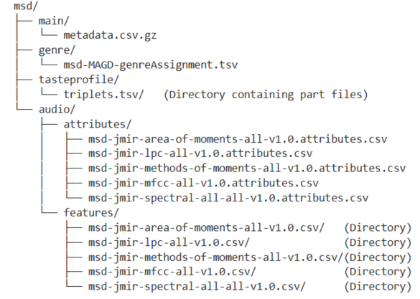

When cross referencing the records, I observed that while the Main dataset contains one million songs, the Audio Features dataset only has 994,623. This means about 5,377 songs are missing, likely because audio samples were not available for all songs, as the Vienna MIR group was only able to obtain audio snippets for 994,960 of the one million tracks. These missing records will be dropped in downstream analysis. Additionally, the Genre dataset contains only 422,714 rows. This will be a strict limit for our supervised learning tasks, as over half of the songs lack the ground truth labels needed to train the model. Lastly, the Taste Profile dataset represents a many to many relationship between users and songs, resulting in its massive size as implicit feedback data. The Taste Profile dataset has 48,373,586 rows because each row records one individual interaction between a user and a song, meaning the same song can appear across many different users, resulting in a much higher row count than the 384,546 unique songs. To prevent out of memory crashes in the upcoming computational stages, I will need to carefully apply data repartitioning and caching strategies.

Q2: Data Preprocessing and Dynamic Schema Definition

To process the audio features efficiently, I first utilize the attributes file that accompanies each dataset. This lightweight file lists the column names and data types in ARFF format. By reading it into memory using the spark.read function and iterating through each row with the toLocalIterator method, I can automatically construct a StructType schema by mapping real types to DoubleType and all other identifiers to StringType. Each resulting StructField is collected into a list and wrapped with a final StructType declaration, producing a precise schema without any manual column definition. This method is much faster and more reliable than using Spark's inferSchema feature, which requires a full data scan and may produce incorrect type mappings.

Although the original names such as Area MethodofMomentsOverallStandardDeviation1 are descriptive and clearly reflect the underlying statistical method, keeping the original column names as they are presents significant disadvantages. They are extremely long and difficult to read, and make it very easy to introduce typos when writing code for machine learning models. Therefore, renaming the columns is necessary. I applied a strategy that combines a dataset specific prefix with a zero padded sequence number, such as A000 for the Area of Moments features and L000 for the LPC features. The zero padding ensures consistent ordering and systematic programmatic access. Since each dataset uses a distinct prefix, columns from different datasets remain uniquely identifiable even after merging, preventing ambiguous column name errors in downstream tasks.

3. Audio Feature Analysis and Genre Classification

Q1: Audio Feature Merger and Statistical Exploration

The five audio feature datasets were extracted from 30 to 60 second audio snippets by the Vienna MIR group using digital signal processing and psychoacoustic modelling. Spectral features capture energy distribution across frequency bands, Area of Moments and LPC describe the shape of the frequency spectrum, Rhythm Histograms summarise rhythmic energy patterns, and Timbral features capture low level characteristics such as roughness and loudness.

When I initially attempted an inner join on the five audio feature datasets, the output unexpectedly resulted in zero rows. This issue occurred because the Rhythm dataset had structural and formatting inconsistencies. Unlike the other files that used the label real, the Rhythm dataset used NUMERIC. This caused the automatic schema generator to misidentify numeric columns as track identifiers. Furthermore, the actual identifier strings contained hidden spaces and single quotes that prevented successful matching in Spark. To resolve this, I extended the type mapping logic to recognize real, numeric, and double. I also applied the trim and regexp replace functions to normalize all ID fields before joining. After these corrections, the final merged audio feature dataset successfully retained 993,828 rows. During this process, I realized that merging five massive datasets creates a very heavy workload for the Spark cluster. Because the data is distributed, Spark has to physically move a huge amount of information across different worker nodes just to match the Track IDs correctly. This massive data moving process is known as network shuffling, and it makes the execution time much longer while taking up significant memory resources. Furthermore, if the data is not saved, Spark will trigger this exact same shuffling process again every time an action is called. To prevent the cluster from repeating this extremely expensive operation in every later modeling step, I immediately cached the final merged dataset in memory. This simple caching step greatly improved the efficiency of the entire workflow.

As shown in Table 2, the descriptive statistics reveal three distinct patterns across these merged audio features. First, some features share similar distributional shapes within the same family. For instance, R030 and R059 have proportionally similar means of 2.69 and 1.63 along with standard deviations of 1.46 and 0.79 respectively. S000 and S008 also show nearly identical standard deviations of 3.57 and 3.81, suggesting consistent patterns within the Rhythm and Spectral families. Second, I observed a vast scale disparity across features. The A019 feature has a massive mean of 1.80E15 compared to a mean of only 1.23 for A000. Additionally, T123 has an extreme maximum of 3223.68 compared to a 75th percentile of just 5.19. These findings confirm that feature standardization is strictly necessary before model training, particularly for Logistic Regression. Third, L019 has all statistics equal to zero, making it a constant feature with no discriminative value. This type of dead feature will be removed prior to modeling.

Finally, to prepare for the classification models, I merged the genre dataset with the cached audio features using an inner join on the Track ID. The resulting dataset contains 420,242 rows. This reduction from 993,828 reflects that only 42 percent of the audio feature tracks have a corresponding genre label in the MAGD dataset.

Table 2
Summary Statistics for Selected Audio Features
Feature | Mean | Std | Min | 25% | 50% | 75% | Max
S000 | 6.929 | 3.57 | 0 | 4.536 | 6.207 | 8.509 | 43.32
S008 | 9.101 | 3.809 | 0 | 6.464 | 8.636 | 11.17 | 55.49
S015 | 26.701 | 10.347 | 0 | 19.15 | 25.91 | 33.07 | 121.4
A000 | 1.229 | 0.53 | 0 | 0.849 | 1.186 | 1.559 | 5.359
A010 | 3.544 | 1.887 | 0 | 2.12 | 3.306 | 4.767 | 19.51
A019 | 1.80E+15 | 1.35E+16 | 0 | 2.19E+14 | 5.94E+14 | 1.83E+15 | 8.24E+17
L000 | 0.0554 | 0.0274 | 0 | 0.0393 | 0.0492 | 0.0626 | 0.492
L010 | -0.971 | 0.035 | -0.997 | -0.984 | -0.975 | -0.964 | 0
L019 | 0 | 0 | 0 | 0 | 0 | 0 | 0
R000 | 10.733 | 4.722 | 2.23E-04 | 7.469 | 10.162 | 13.322 | 44.272
R030 | 2.686 | 1.506 | 2.23E-04 | 1.786 | 2.441 | 3.226 | 31.329
R059 | 1.637 | 0.787 | 2.23E-04 | 1.127 | 1.534 | 2.004 | 9.851
T000 | 0.0917 | 0.0401 | 0.00195 | 0.062 | 0.0869 | 0.117 | 0.473
T062 | 0.031 | 0.015 | 0 | 0.021 | 0.0284 | 0.038 | 0.308
T123 | 8.156 | 48.026 | 0 | 0.84 | 1.968 | 5.187 | 3223.679

Out of 190 sampled feature pairs, 22 pairs exceeded a Pearson correlation threshold of |r| > 0.7, with strong correlations concentrated within the Spectral and Area families. Comparing Figures 2 and 3, the reduction in multicollinearity after feature removal is clearly visible. Before removal, the Area and Spectral families each form large blocks of deep red, indicating strong internal correlations across multiple features. After removal, these dense clusters are significantly reduced, with far fewer deep red cells remaining. Notably, the number of features along both axes decreases. To address multicollinearity, strongly correlated features were removed before model training, ensuring that the remaining features carry more independent information for the classifier. Reducing multicollinearity is particularly important for Logistic Regression, as highly correlated features can cause unstable coefficient estimates during training.

Figure 2
Feature Correlation Heatmap (Before Removal)
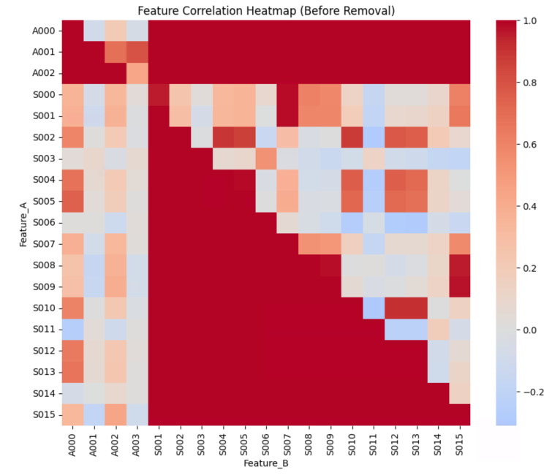

Figure 3
Feature Correlation Heatmap(After Removal)
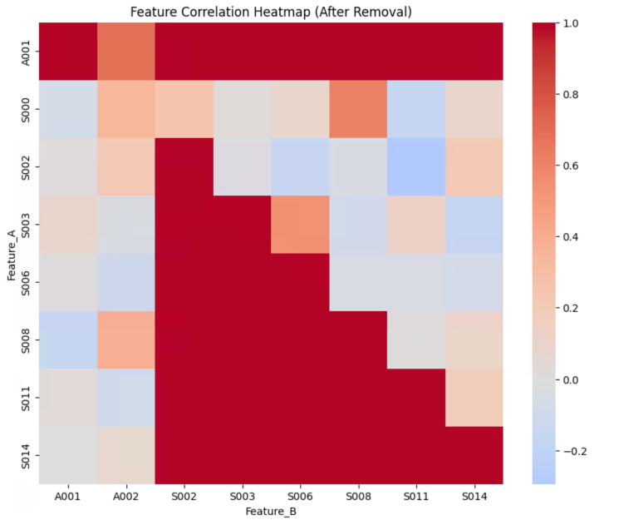
Figure 4 shows an extreme imbalance in the genre distribution across this dataset. The vast majority of the music is labeled as Pop_Rock. In this situation, there is a significant risk that the machine learning model could easily achieve a deceptively high accuracy simply by guessing this most frequent music genre every time. This creates a false sense of success without the model actually learning the underlying audio patterns. As a result, during the evaluation step, I cannot rely solely on the raw accuracy score. Instead, I must use more robust metrics like the F1 Score or the Area Under the ROC Curve to properly examine the performance of the model.

Figure 4
Genre Distribution (Imbalance Check)
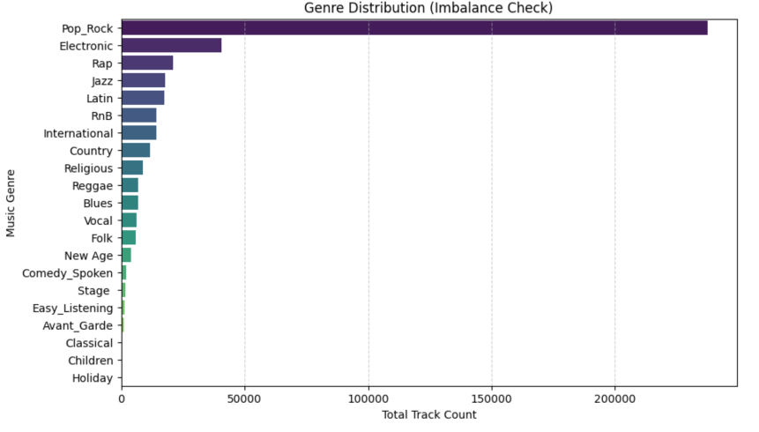

Q2: Binary Classification Modeling (Rap vs. Others)

These three algorithms were chosen because they represent a range of complexity and interpretability, allowing for a meaningful comparison between a linear baseline, an ensemble method, and a boosting approach. As summarised in Table 3, Logistic Regression serves as a baseline model due to its high interpretability and fast training speed. It requires feature standardisation before training, as it is sensitive to feature scale and multicollinearity in high dimensional feature spaces. A StandardScaler was therefore applied in the training pipeline. Random Forest addresses non-linear relationships through ensemble learning and random feature selection, which reduces the risk of overfitting. GBT Classifier generally achieves the highest predictive accuracy by sequentially correcting errors from previous trees, but it is the slowest to train and requires the most memory, and its low interpretability makes it a black-box model. All three algorithms are capable of handling high dimensional feature spaces, which is essential given that the merged audio feature dataset contains approximately 240 features.

Table 3
Comparison of Classification Algorithms
Algorithm | Interpretability | Training Speed | Feature Scaling | Advantages | Disadvantages | When to Use
Logistic Regression | High | Very Fast | Required | Highly interpretable coefficients; fast training; easy to regularize | Limited ability to model non-linear relationships; sensitive to multicollinearity | Good baseline model; use when interpretability is important and features are standardized
Random Forest | Medium | Fast | Not Required | Handles non-linear relationships well; robust to noise and outliers | Less interpretable than LR; may overfit if trees are too deep | Strong general purpose classifier; good when dataset has many features and non-linear patterns
Gradient Boosted Trees | Low | Slow | Not Required | Often highest predictive accuracy; models complex non-linear patterns; boosting reduces bias and variance | Slowest to train; sensitive to hyperparameters; can overfit if not tuned properly | Best when accuracy is the priority; use when computational resources allow for tuning

The labelled dataset was split into 80% for training and 20% for testing using a stratified random split to preserve the class ratio in both sets. The dataset contains a significant class imbalance, with 20,871 Rap tracks and 399,371 non-Rap tracks, resulting in a ratio of approximately 1:19. Without correction, this imbalance can cause accuracy inflation, where the model achieves deceptively high accuracy by simply predicting the majority class. Observation weighting was chosen over subsampling and oversampling because it assigns higher penalties to misclassified Rap tracks during training without modifying the underlying data distribution, avoiding both information loss and overfitting.

Training all three models in a distributed Spark environment required careful parameter tuning to prevent out of memory errors. Logistic Regression was the most stable and lightweight, and maxIter was set to 20 to ensure smooth convergence under memory constraints. Random Forest required significantly more memory, so numTrees was restricted to 10 and maxDepth to 8 to maintain computational stability while retaining predictive performance. GBT was the most memory intensive due to continuous gradient statistics maintenance. As Spark's GBT implementation lacks native support for observation weighting, this model relied entirely on the stratified split quality. maxDepth was set to 2, maxIter to 10, and maxBins to 16 to prevent failures during boosting iterations.

The model performance is shown in Table 4. GBT achieved the highest accuracy and recall at 0.9561, confirming its ability to capture complex patterns through sequential boosting. However, in this imbalanced dataset where 95% of tracks are non-Rap, raw accuracy is a misleading metric, a model predicting non-Rap for every track would still achieve 95% accuracy without learning anything meaningful. Recall is therefore critical, as it validates whether the model has genuinely learned to identify the minority class. The high recall across all three models confirms the effectiveness of observation weighting. Despite its lower raw accuracy, Logistic Regression achieves the highest AUROC of 0.9417, making it the most reliable model for this task. AUROC measures the probability that the model ranks a Rap track higher than a non-Rap track regardless of threshold, providing a fairer evaluation under class imbalance. Random Forest achieved a moderate AUROC of 0.9227, likely due to the conservative memory constraints limiting it to 10 trees and a depth of 8.

Table 4
Binary Classification Performance on the Test Set
Algorithm | Accuracy | Precision | Recall | AUROC
Logistic Regression | 0.9029 | 0.9597 | 0.9029 | 0.9417
Random Forest | 0.9333 | 0.9565 | 0.9333 | 0.9227
GBT Classifier | 0.9561 | 0.9486 | 0.9561 | 0.9047

Q3: Multiclass Genre Classification Modeling

Logistic Regression supports multiclass classification natively in Spark ML, which automatically switches to multinomial logistic regression when more than two labels are detected. It can also use a One vs Rest strategy. For this to work well, several assumptions must be satisfied. Features should not be highly correlated, each observation must be independent, and a linear relationship must exist between each feature and the log odds of each class. It also assumes independence of irrelevant alternatives, meaning adding a new class should not alter the relative probabilities between existing classes.

When I converted the genre column from binary to multiclass, the effective class balance worsened significantly. In the binary task, Rap accounted for approximately five percent of the data with an imbalance ratio of 1 to 19. In the multiclass setting, the Others class was split into 19 separate genres. Pop Rock dominates with 57 percent of the data, while Children contains only 0.11 percent, causing the imbalance ratio to deteriorate to approximately 1 to 513, making the classification task considerably more challenging.

My multiclass Logistic Regression achieved an overall accuracy of 0.68, a weighted precision of 0.63, a weighted recall of 0.68, and a weighted F1 score of 0.63. However, I noticed that these aggregate figures hide highly uneven results across genres. As shown in Table 5 and Figure 5, Rap and Pop Rock achieved nearly perfect F1 scores of 1.00 and 0.93 respectively because of their dominant presence in the training data. Mid tier genres such as Comedy Spoken and Electronic achieved moderate scores, likely because they have distinctive acoustic signatures. In contrast, rare genres like Avant Garde, Children, and Holiday received an F1 of zero. Under the One vs Rest strategy, a rare genre like Children faces an extreme imbalance of 1 to 863. I realized the model takes an easy shortcut to maximize accuracy by simply predicting negative for every song. This guessing catches no real songs, yielding zero true positive predictions. Consequently, precision, recall, and the final F1 score all drop to exactly zero. Compared to the binary task F1 of 0.96, this dramatic performance drop confirms that resampling or class weighted training is essential to learn a reliable decision boundary.

Table 5
Performance Metrics by Genre for Multiclass Logistic Regression
genre | precision | recall | f1
Avant_Garde | 0 | 0 | 0
Blues | 0.133188 | 0.133188 | 0.133188
Children | 0 | 0 | 0
Classical | 0.085937 | 0.085937 | 0.085937
Comedy_Spoken | 0.562044 | 0.562044 | 0.562044
Country | 0.140954 | 0.140954 | 0.140954
Easy_Listening | 0.006472 | 0.006472 | 0.006472
Electronic | 0.496415 | 0.496415 | 0.496415
Folk | 0.029851 | 0.029851 | 0.029851
Holiday | 0 | 0 | 0
International | 0.058635 | 0.058635 | 0.058635
Jazz | 0.479161 | 0.479161 | 0.479161
Latin | 0.233559 | 0.233559 | 0.233559
New Age | 0.178808 | 0.178808 | 0.178808
Pop_Rock | 0.931601 | 0.931601 | 0.931601
Rap | 1 | 1 | 1
Reggae | 0.479462 | 0.479462 | 0.479462
Religious | 0.006142 | 0.006142 | 0.006142
RnB | 0.175844 | 0.175844 | 0.175844
Stage | 0.073579 | 0.073579 | 0.073579
Vocal | 0.142045 | 0.142045 | 0.142045

Figure 5
Per-Genre F1 Score for Multiclass Logistic Regression
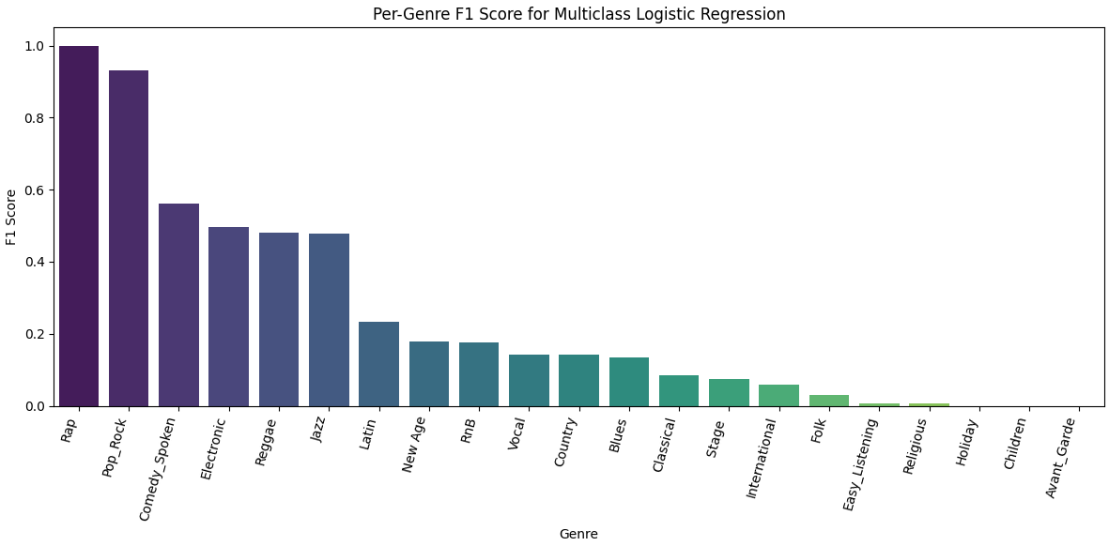

Q4: Hyperparameter Tuning and Optimization Strategy

If I could revisit the hyperparameter settings in the previous binary and multiclass tasks, I would adopt a more aggressive tuning strategy for both tasks. The hyperparameters used previously were chosen conservatively to manage memory and training time constraints in Spark. With more resources, a more aggressive tuning strategy would be preferable. Table 6 summarises the key hyperparameters for each algorithm.

Table 6
Key Hyperparameters for Each Classification Algorithm
Algorithm | Hyperparameter | Definition | Effect on Performance
Logistic Regression | maxIter | Maximum optimisation iterations | More iterations improve convergence on high dimensional data
Logistic Regression | regParam | L2 regularisation strength | Reduces overfitting in 240 dimensional feature space
Logistic Regression | elasticNetParam | L1/L2 mixing ratio | L1 component enables feature selection, zeroing irrelevant audio features
Random Forest | numTrees | Number of trees in ensemble | More trees reduce variance and stabilise decision boundaries
Random Forest | maxDepth | Maximum depth per tree | Deeper trees capture complex feature interactions among 240 audio features
Random Forest | featureSubsetStrategy | Features considered per split | Restricting features increases diversity between trees, improving stability
GBT | stepSize | Learning rate | Lower values allow finer gradient updates, preventing oscillation
GBT | maxIter | Number of boosting rounds | More rounds help correct misclassifications of minority class samples

For the binary classification task, if I could redo the tuning, I would focus on the GBT classifier. I would lower stepSize from 0.1 to 0.05 and raise maxIter from 10 to 100. A smaller step size means the model updates itself more carefully each round, which gives it more chances to learn the patterns of the rare Rap tracks instead of simply predicting the majority class every time. For the multiclass task, I would tune regParam and elasticNetParam for Logistic Regression, since both were left at default values. Increasing regParam adds regularisation, which penalises the model for relying too heavily on any single feature. This is useful here because many of the 240 audio features are likely correlated, and regularisation helps the model focus only on the most informative ones.

To compare parameters fairly, I would use k fold cross validation. A single split is risky because a lucky selection might inflate scores for rare genres. This method divides the data into k equal pieces, training on k minus one and testing on the remaining piece iteratively. Averaging the scores ensures a stable and honest evaluation. For example, I would test a few values of regParam such as 0.01, 0.1, and 1.0 to find the most promising range, then narrow it down from there. The best performing combination would then be used to retrain the final model. Since deeper models can cause memory issues in Spark, I would also apply checkpointing to keep the job stable. Overall, I expect tuning to improve the binary task by up to ten percent, but only one to five percent for the multiclass task, as the main issue there is the lack of training samples for rare genres.

4. Collaborative Filtering and Song Recommendation System

Q1: Dataset Attributes and Long Tail Distribution Analysis

Handling 48,373,586 records with only a 1GB memory limit is risky. Under the default few partitions, each task takes on too much data and crashes. By repartitioning into 400 parts, each node only processes about 120,000 rows at a time, which is very safe. Furthermore, the Alternating Least Squares (ALS) algorithm loops through the data many times. Without caching, Spark wastes time recalculating everything from scratch for every loop. To prevent this, I persisted the data. I chose memory and disk storage so that if the RAM fills up, the excess data safely spills to the hard drive instead of being dropped, keeping the training fast and stable.

The dataset contains 384,546 unique songs and 1,019,318 unique users. The most active user listened to 4,400 unique songs, which accounts for only 1.14% of all songs in the dataset. This already suggests that the data is extremely sparse, as even the most engaged user has only explored a tiny fraction of the available music.

Table 7 presents the descriptive statistics of the playcount variable. The count of 48,373,586 represents the total number of user song interaction events recorded in the dataset. The median is 1 and 90% of interactions have a playcount of 6 or below, meaning most users only played a song once or a few times. This heavily right skewed distribution shows a few users looping songs endlessly. A maximum of 9,667 plays is completely unnatural for humans. It is most likely a bot, a store playing background music, or a data error.

Table 7
Descriptive Statistics of Playcount
statistics | value
Count | 48373586
Mean | 2.87
Median | 1
P90 | 6
P99 | 24
Max | 9,667
Stddev | 6.44

I defined song popularity as the number of unique users who played a song, and user activity as the number of unique songs a user played. Figure 6 shows the distributions of song popularity and user activity on a log-log scale. In both plots, the points form a near straight line, which indicates a power law distribution. Most songs were only played by one or two users, and most users only listened to a small number of songs. Only a tiny fraction of songs and users appear at the high end of the scale. This heavy tailed pattern is typical of music listening data, and suggests that the interaction matrix is extremely sparse, which is an important consideration when building a recommendation model. Retaining these extremely sparse interactions would introduce noise and weaken the model, which is why filtering users and songs with fewer than 20 interactions is necessary.

Figure 6
Song Popularity and User Activity Distributions (Log-Log Scale)
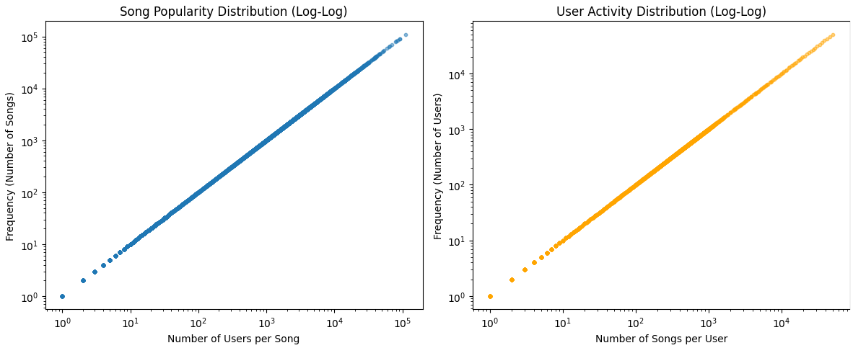

Q2: Training and Evaluating Implicit Alternating Least Squares (ALS) Model

To reduce sparsity and noise, I filtered out users who had interacted with fewer than 20 songs and songs played by fewer than 20 users. These thresholds are reasonable because the power law distributions established in the initial analysis show that highly sparse interactions contribute little signal to the model. As shown in Table 8, this retained 661,103 users and 161,173 songs. Since the Alternating Least Squares algorithm requires integer identifiers, I used a string indexer to map each user and song to a consistent integer index. I realized that if a user only appears in the test set, the algorithm has never seen them during training and therefore cannot create a latent vector for them. Without this latent vector, the model is completely unable to generate any recommendations. To prevent this cold start failure, I used a window function to randomly rank each user interaction history and forced the first row of each user into the training set before splitting the remaining data into an 80 to 20 ratio. This ensures the model successfully learns a latent vector for everyone, resulting in 33771249 training records and 8281282 test records.

Table 8
Dataset Statistics After Filtering
Users | Songs
Original | 1,019,318 | 384,546
Retained | 661,103 | 161,173
Excluded | 358,215 | 223,373

Table 9 shows that Precision at 10, Mean Average Precision at 10, and NDCG at 10 are all zero. Precision at 10 measures what fraction of the top 10 recommendations were actually played, Mean Average Precision considers the ranking position of each hit, and NDCG gives higher weight to hits appearing earlier in the list. Although recommended songs did not exactly match the test set history for sampled users, a qualitative metadata comparison showed the model successfully captured underlying preferences. For example, User 5 primarily listened to energetic Pop Rock and Electronic tracks. The model accurately recommended new artists within those exact genres sharing similar upbeat tempos. This proves the model learned true user preferences and suggested highly relevant tracks they had not yet discovered.

Table 9
Ranking Metrics of the ALS Model on the Test Set
Metric | Value
Precision@10 | 0
MAP@10 | 0
NDCG@10 | 0
To train the model, I set the ALS parameters to a rank of 20, a maximum iteration of 10, a regularization parameter of 0.1, and an alpha of 40. The rank and iterations control model complexity and convergence. Most importantly, because play counts are implicit feedback, the alpha parameter of 40 acts as a confidence weight, meaning the model prioritizes songs that a user loops repeatedly rather than treating play counts as a direct preference score. The model also suffers from popularity bias, tending to recommend already popular songs while rarely surfacing long tail tracks. Additionally, matrix factorization requires significant computation across many iterations, making real time updates impractical in production. For new users with no history, a popularity based fallback would be needed, while new songs could be handled using audio similarity from content based filtering. In practice, A B testing with online metrics such as click through rate and listen completion rate would give a more meaningful measure of real world recommendation quality.

5. Conclusions

In this project, I successfully used Spark to clean the large Million Song Dataset, merging different datasets by automatically renaming columns and creating schemas. This preparation significantly supported the following machine learning stages. I also learned that strategies like observation weighting can effectively address imbalanced data, and that in multiclass situations, imbalance becomes even more challenging. Cross-validation was necessary to tune parameters and improve performance.

After the classification tasks, I built a collaborative filtering recommendation system using the Alternating Least Squares algorithm. By observing the power law distribution in the play counts, I filtered out inactive users and unpopular songs to remove noise. I also applied Spark techniques like repartitioning and caching, which prevented memory crashes when processing millions of implicit interaction records and kept the model training stable.

Overall, this project taught me that understanding data distribution is just as important as writing code. Even though the offline ranking metrics returned zero, this is a known limitation of evaluating implicit feedback models on sparse test sets rather than a reflection of poor model quality. I also realized that to truly evaluate a recommendation system, we must rely on real world A B testing to see how real users interact with the results.

6. References
I used Gemini as a supporting tool for this project. Specifically, it assisted in debugging PySpark code errors, provided suggestions for improving English grammar and sentence flow, and helped organize the logical structure for the final report.

